
version
1.0β
Bilkent University
Center for Bioinformatics

PATIKA Client
User’s Guide
Bilkent University - Center for BIOInformatics
PATIKA Client User’s Guide
© PATIKA 2002
Bilkent University • Center for Bioinformatics
Phone (312) 290 2504 • Fax (312) 266 4047

Table of Contents
1 Overview 5
1.1 Motivation and Goals 5
1.2 Overall Architecture 5
1.3 User Types 6
1.4 Main Features 7
1.5 Pathway Editing and Automated Layout 8
1.6 Querying Database 8
1.7 Implementation 9
2 PATIKA Ontology 10
2.1 An Ontology for Cellular Processes 10
2.2 Bioentities 12
2.3 PATIKA Graphs 12
2.4 Compartments and Cell Models 13
2.5 Abstractions 13
2.6 Summaries 13
3 Pathway Creation and Manipulation 16
3.1 Creating and Manipulating PATIKA Graphs 16
Editing Modes 17
Resizing Compartments 18
3.2 States 19
Creating States 19
Deleting States 24
Modifying State Properties 25
3.3 Transitions 25
Creating Transitions 25
Deleting Transitions 27
Modifying Transition Properties 27
3.4 Interactions 27
Creating Interactions 27
3.5 Bioentities 29
Creating New Bioentities 30
Deleting Bioentities 30
Modifying Bioentity Properties 30
3.6 Invalid PATIKA Graph Topology 30
3.7 Saving and Restoring PATIKA Graphs Locally 30
4 Pathway Editing and Automated Layout 32
4.1 Pathway Editing 32
Moving 32
Scrolling and Zooming 33
4.2 Automated Layout 35
5 Updating Pathway Contents 37
6 Querying the PATIKA Database 40
6.1 Finding Neighbors 40
6.2 Querying Bioentities 41
6.3 Querying States 42
6.4 Specialized Queries 44
Finding Neighboring States 45
Finding Paths Between States 46
7 Populating the PATIKA Database (Research & Expert Users Only) 49
7.1 Logging On 49
7.2 Submitting a PATIKA Graph 50

Preface
technical specifications
The PATIKA Client requires JDK 1.3 or higher to run. It does not impose any limitations on the size of the PATIKA graphs; they can contain as many biological objects or interactions as the available memory permits.
LAUNCHING PATIKA CLIENT
You are required to register before you can download the PATIKA Client. Once you have registered, you will be automatically sent a message including a password and download instructions. After you agree to the PATIKA Licensing Agreement and download the software, you may install and launch the PATIKA Client using one of the following methods:
- InstallAnywhere
- Web Start
- Batch file
The related web site and the detailed instructions for installation and execution of the PATIKA Client will be sent via email.
About the documentation
PATIKA Client User’s Guide is part of a document set published by the PATIKA group in Bilkent Center for Bioinformatics. The following additional document is provided as part of the product distribution:
- Online Help: [TODO]
Throughout this document, you will occasionally see parts highlighted in red and blue. The red parts should be ignored for this particular revision, whereas the parts in blue point out the differences between this revision and the revisions to come later.
Contacting US
We believe user input is essential to successful product development. Please contact us with any questions or comments and visit our web site.
Web site | http://www.patika.org
Email | patika@cs.bilkent.edu.tr
Mailing Address | Bilkent Center for Bioinformatics,  Bilkent University, Ankara 06533, Turkey
Telephone and Fax | +90 (312) 290 2504 and +90 (312) 266 4047

Overview
Chapter
1
This chapter introduces PATIKA (Pathway Analysis Tool for Integration and Knowledge Acquisition) and presents the project objectives. In addition, it describes the overall architecture and main features of PATIKA.

Motivation and Goals
Availability of the sequences of entire genomes shifts the scientific curiosity toward the identification of function of the genomes in large scale as in genome studies. In the near future, data produced about cellular processes at molecular level will accumulate with an accelerating rate as a result of proteomics studies. In this regard, use of tools for storing, integrating, accessing, and analyzing this data effectively seems essential.
The PATIKA ontology (Chapter 2) is a comprehensive representation of cellular events, which enables integration of fragmented or incomplete pathway information and supports manipulation and incorporation of the stored data, as well as multiple levels of abstraction. The integrated environment named PATIKA is based on this ontology. PATIKA is composed of a server-side, scalable, object-oriented database and client-side editors to provide an integrated, multi-user environment for visualizing and manipulating network of cellular events. PATIKA client features automated pathway layout, functional computation support, advanced querying and a user-friendly graphical interface.
It is hoped that PATIKA will be a valuable tool for rapid knowledge acquisition, micro array generated large-scale data interpretation, disease gene identification, and drug development.

Overall Architecture
Considering the current pace of the biological research, it is very important to distribute new knowledge quickly. Past experience hints that the most efficient method for this is public databases where users may submit recently discovered information. Public databases also offer a single organized source reducing the time spent on literature search. Since the nature of the data is highly interrelated, this database should be necessarily curated.
Given the fact that the data is fairly complex a user probably would not be able to analyze all of the available information at once. Thus it is crucial to provide facilities for querying and navigating the database. A user should be able to perform queries on the database, retrieve the relevant subset of the database, view the query results pictorially, and analyze it. It is also essential to provide users with means to submit new information to the database, or modify an existing entry. These tasks require a potent editor, which is tightly integrated to the database. Furthermore such a tool should provide support for functional computation (e.g., simulations) and large-scale data analysis.
Any such tool clearly needs to be internet-based, facilitating easy retrieval of the required information for analysis as well as sharing of the information. It should also facilitate plug-in of any new components. It is expected that development of such databases and tools will be one of the major research subjects in bioinformatics for the near future.
PATIKA is an integrated software environment designed to provide researchers a complete solution for modeling and analyzing cellular processes. The PATIKA project aims to build a public database of all cellular processes using a regular, simple yet comprehensive model.
PATIKA uses a client-server architecture for achieving this task (Figure 1-1). The server acts as a common database and manages queries and submissions as well as users. The PATIKA client, on the other hand, communicates with the server through the proxy and provides a user-friendly interface for querying, retrieving, and manipulating pathway information from the database.
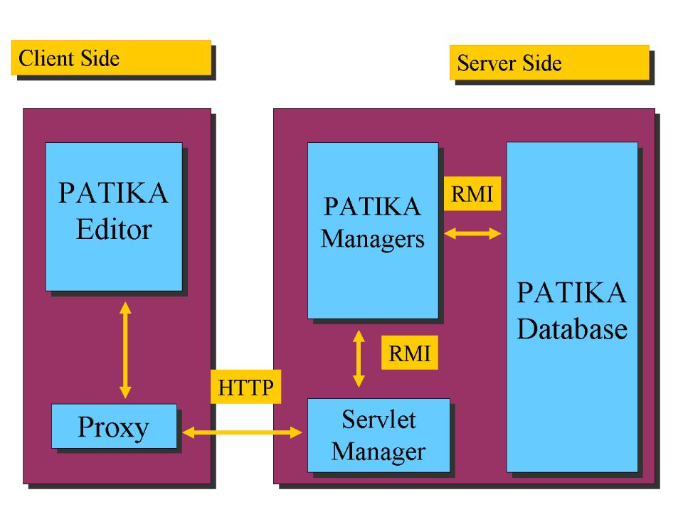
Figure 1-1 Overall Architecture of PATIKA.
A PATIKA session is started when a user executes the client application. The user can connect to the server and query the database to construct the desired pathway. Pathways are created on the fly, and drawn automatically. A user can analyze and manipulate the data or may add new information. Finally the resulting pathway may be stored locally or submitted to the database.

User Types
Building such a database requires a collaborative effort; so, it is very critical to allow users to submit new data. However in order to preserve the integrity of the database, submissions are required to be processed before they are incorporated to the database. PATIKA has three different types of users with different levels of access (Table 1-1).
User Type | Typical Role | Access Level
Regular | Medical Doctors & Students | Read
Research | Graduate Students & Researchers | Read & Submit
Expert | Experts in Particular Domain | Read & Submit & Write
Table 1-1 User Types and Varying Access Levels.
By default users are only granted read access; that is, they may perform local operations such as pathway editing and may query the PATIKA database but may not make submissions to modify the database contents.
If you would like to gain submission privileges, you need to contact the PATIKA staff.

Main Features
The client side editor provides means for analyzing and manipulating pathways visually. It is particularly designed for minimizing modeling time for the users and to allow them to effectively construct and analyze pathways (Figure 1-2).
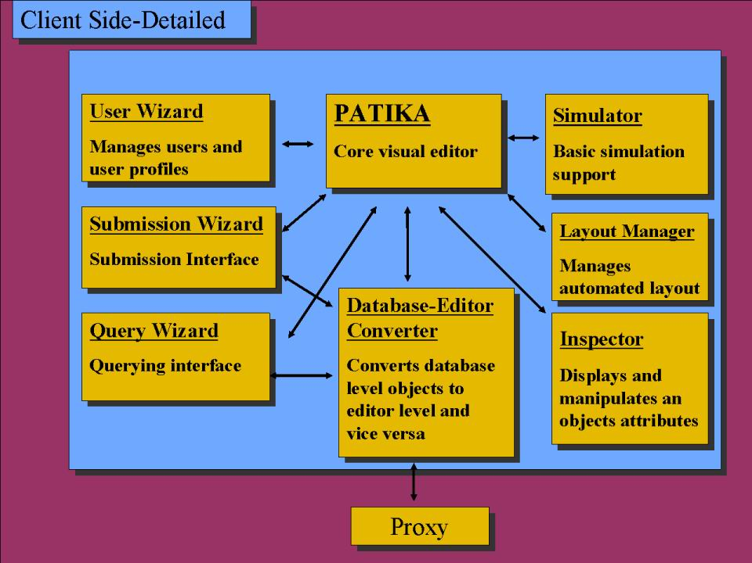
Figure 1-2 PATIKA Client Architecture.
PATIKA provides most of the functionalities of a graph drawing tool such as zooming, scrolling, selection, dragging, event-handling, and persistent storage.
Once a pathway is constructed either manually and/or through a query on the database, the user can:
- manipulate this pathway through operations such as add new state or remove an existing transition,
- edit its contents such as the description of a state or transition,
- change the graphical view of a pathway component,
- define a new pathway from a part (i.e., subgraph) of an existing pathway,
- submit the pathway to the database to commit the changes to the database so they can be shared with others. PATIKA uses a three-level check mechanism to ensure that a new submission can be safely integrated into the pathway network. In the first level it is checked whether the submission complies with the PATIKA model, while the second level checks for database objects that are not present in the submission but are in the immediate neighborhood of the modified objects (Figure 2-5). Finally an expert user (Table 1-1) verifies whether the submission is biologically accurate. First two checks are performed programmatically and a proper feedback is sent back to the user for any corrections that might be required. Once these inconsistencies are fixed, the server stores the submission in a separate database and alerts the related experts. As soon as the submission is validated by an expert, it is merged to the PATIKA database,
- save the pathway along with its geometric information on disk for later use.
Independent of the user access level, all of these functions are essential since PATIKA is also a workbench where biologists may evaluate their ideas. Adding and removing entities or interactions may require update of the condition for presence (activation) of states (transitions).
Each pathway document in the editor has an associated cell model, which defines how the cell and its compartments should be drawn on the screen. The default cell model is the one for humans. However, new cell models for other organisms may be easily defined and integrated into the editor.

Pathway Editing and Automated Layout
PATIKA facilitates editing of pathway drawings through operations such as dragging of biological objects, zooming, scrolling, and automated layout. It provides specialized algorithms for layout of cellular pathways to produce – on the fly – aesthetically pleasing drawings of pathways that are easy to comprehend.

Querying Database
Since the projected network of pathways for an organism is vast, searching tools are essential for deducing useful information from this data. The editor has an integrated querying tool that allows the query of the PATIKA database. The editor sends the query in the form of a string and the result is returned as a pathway that is created dynamically by the server based on the query. As the pathway is received by the editor, it is automatically laid out to assign drawing information for a comprehensible display.
Pathways resulting from a query may be further extended by follow-up queries or by manual editing.
Queries not only provide means for accessing the needed entries in the database but also discovering relations that were not noticed before. Since the case we are dealing with is quite unique we need sophisticated query operations along with basic field searches. Examples include:
- search for pathways containing certain states or transitions,
- find states that a certain transition takes or produces or is affected by,
- search for paths between two states or transitions,
- find the shortest path between two states or transitions,
- search for states and/or transitions in a certain neighborhood of a state or transition.
Users can combine queries with basic Boolean operations (AND, OR, NOT) to produce more advanced ones.
The query processing is designed to handle multiple queries running on the database simultaneously. However it is essential that these algorithms are efficient; the theoretical computational complexity of currently implemented query algorithms range from linear to cubic.

Implementation
PATIKA has been designed and is being implemented using an object-oriented approach in pure Java. Other than standard Java libraries and Swing™, PATIKA uses Tom Sawyer Software's Graph Editor Toolkit for Java™ for the basic graph modeling and editing and ObjectStore™ for database management (currently MySQL is used for maintenance and management of user data).
Communication between the server and the client is based on servlets using Tomcat and done via HTTP while intra-server communication is handled via Java's RMI (Remote Method Invocation) technology, facilitating the distribution of the server to multiple machines.

PATIKA Ontology
Chapter
2
This chapter discusses the PATIKA ontology, an improved ontology for cellular pathways.

An Ontology for Cellular Processes
In a cell, decision mechanisms are governed by molecules. A molecule starts its life cycle by either being synthesized from its precursors or transported into the cell, then it goes through a series of transitions. Examples of such transitions include group addition and removals, isomerisations, complex formations and transportations. Each transition changes the information carried by the molecule, transforming it into a new state like phosphorylated state of a protein or a certain splice form of RNA. A molecule's life cycle ends either by being degraded or transported out of the cell. A molecule may go through a certain set of possible transitions under a specified physiological condition and a totally different one under another condition. In fact this is the very mechanism of cellular regulation (Figure 2-3).
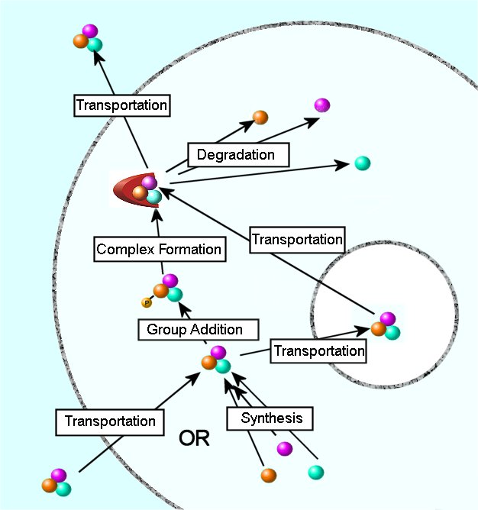
Figure 2-3 Life Cycle of a Molecule.
A very intuitive and widely accepted representation for cellular processes is in the form of directed graphs where nodes correspond to molecules and edges correspond to interactions between them. This representation is limited in the sense that it only uses one node per molecule, not facilitating the representation of different states of the molecules. Sometimes so-called active and inactive states are represented separately, which is an incomplete solution since a molecule has often more than two states. Consequently some prior knowledge is often required to correctly interpret these graphs. These representations also use hyper-edges extensively, in order to represent interactions involving more than two molecules. This poses another restrain for visualization and analysis. Although these problems may not have been significant so far due to relatively less complexity of the data, they surely will become so as the average number of molecules per pathway increases.
We propose to represent each state and transition as a separate node in the graph (Figure 2-4). A state can be a macromolecule, a small molecule, a complex or even physical phenomena such as light. A transition represents group additions or removals, complex formations and disassociations as well as transportations and other cellular events. This model is very similar to the chemical equations of the form
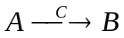
where  is a substrate,  is a product and  is an effector. This analogy is very useful since most of the biological reactions are essentially chemical reactions. Other non-chemical phenomena like transportation can be described with this ontology as well (Figure 2-4).
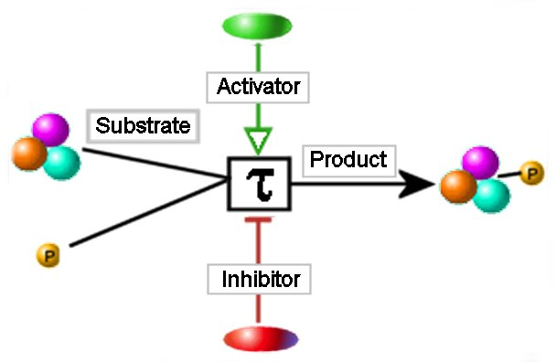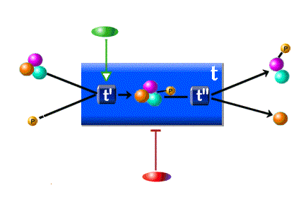
Figure 2-4
(left) A basic, robust ontology for cellular processes. A molecule may have any number of states to depict changes in its information context. A transition, represented as a distinct type of node, provides a convenient mean for conveying event-specific information like reaction constants or the complex regulatory behavior. Each transition has a number of associated states, which may be products, substrates or effectors of the transition. These relations are represented by different edge types.
(right) The model also supports abstraction and representation of incomplete information through nesting.
Changes in the sub-cellular location of a molecule are regarded as a change in its information context. In order to reflect these changes each state is associated with exactly one compartment such as cell membrane, nucleus or mitochondria.
A pathway graph 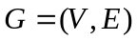 is defined by a finite set  of states and transitions and a finite set  of interactions between these states and transitions (e.g., inhibition). A pathway is an abstraction of a certain biological phenomena and is the uppermost abstraction in our biological hierarchy. Its context can change from a single molecule-molecule interaction to a complete set of all the interactions in a cell. A pathway may contain other pathways, and in turn may be a subset of another pathway. This nesting mechanism provides multiple levels of abstraction as well as facilitating the representation of incomplete information (Figure 2-4). Nesting is essential for analyzing cellular mechanisms since the complete network of cellular events is clearly beyond human perception. To be more precise, in our ontology, a pathway is defined by a compound graph 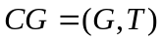 where  is a pathway graph 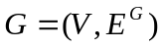 as defined above and 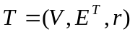 is a tree rooted at , sharing the same set of nodes with . Essentially defines an interaction graph and the tree is a decomposition tree, defining desired multiple levels of abstraction.
An important consideration in the design of such an ontology is ease of integration of new data. Since the entire pathway network is considerably large, a user will normally work on a relatively small subgraph of this network. Once the modifications are made, they need to be integrated to the database such that the pathway network remains intact with valid topology. PATIKA ontology uses an atomic approach of defining consistency, checking only the immediate neighborhood of each object. That is, only the associated interactions (incident edges) of a state or transition (node) are used to decide whether its topology is valid. Thus, when merging pathways one needs to check only those objects that are modified along with their immediate neighborhood.

Bioentities
PATIKA ontology defines multiple states for a single entry in most of the biological databases (i.e., RNA, DNA and multiple forms of the protein product of a gene is represented as a single entry in Swiss-Prot). In order to model this conventional grouping, PATIKA uses bioentities, set of states that are traditionally grouped under a single title. Bioentities are most useful and populated for macromolecules where a single information base (genetic code) leads to multiple states.
It is critical to be able to access as much information as possible about the states in order to be able to encompass most of the biological information that is already available. In order to achieve this goal PATIKA maintains cross-links to other biological databases through its bioentities.

PATIKA Graphs
A PATIKA graph or simply PatGraph is a bipartite graph of states and transitions. It defines a certain abstraction of a biological phenomenon, which is made up of a complete or partial pathway or possibly multiple inter-related pathways. The union of all possible PATIKA graphs forms the “big picture” that defines all the interactions in a cell. Each element of the model is defined in the context of a PATIKA graph. In that sense, PATIKA graph is the central element of our ontology.
Each PatGraph maintains a list of states, transitions, and interactions as well as the associated bioentities. It has a cell model defining the structure of the cell for which this PATIKA graph is defined.
PATIKA graphs may contain other PATIKA graphs via summaries that are possibly nested.
We believe that the resulting model is flexible enough to encompass most of the biological phenomena while maintaining a well-defined and comprehensible structure.

Compartments and Cell Models
A cell has a structure defined by compartments like organelles, membranes, and regions, and their neighborhoods. A change in the compartment of a state is considered as a change in its information content since it restricts the molecules it may interact with. For example, normal cyctochrome C in mitochondria having a role in the metabolism induces apoptosis if it is released to the cytoplasm. Similarly, most transcription factors, when activated, translocates to nucleus to induce gene expression.
Each state in the PATIKA model has a compartment. A compartment has a set of neighboring compartments (e.g., cytoplasm and cytoplasm membrane) with which interactions are possible. States may pass through transportation transitions to create new states in a different compartment.
Structure of cells may differ greatly even between tissues in an organism. Neurons for example differ considerably from lymphocytes. Discrepancies between different organisms, as in the case of eukaryotes and prokaryotes, can even be more drastic. A cell model is a formal definition of the structure of the cell. It defines compartments and their definitions. A PATIKA graph has an associated cell model, and each of its states is assigned a compartment of this model.
Current implementation supports only the cell model for humans.

Abstractions
There are cases where an abstraction for a certain series of events is necessary (e.g., apoptosis or glucose metabolism). Details of these processes are rarely of interest to a user, and it is meaningful to represent them as abstract states or transitions, with the details hidden. However, it is also important to be able to reveal the details whenever the mechanism becomes important to the user. PATIKA allows users to define abstractions, which are arbitrary groups of states, transitions and other abstractions. Commonly used types of cellular pathways (e.g., p53 pathway) may be represented with abstractions. Users can nest such abstractions in order to achieve multiple representation and abstraction levels. Abstractions can also be part of queries (e.g., “find all paths between p53 pathway and NFkappaB pathway” provided that there exists two abstractions with mentioned names, respectively). At the editor level, abstractions can be “collapsed” or “folded” to condense trivial pathways or obtain a less-detailed view of events in a cell.
Abstractions are not considered to be states or transitions; thus they cannot accept edges. The contents of abstractions may overlap at the database level but currently there is no support for display of such overlaps at the editor level.

Summaries
A summary is a set of states and transitions with certain restrictions that facilitate modeling of incomplete information. They also introduce two new types of interactions: intergraph (or interpathway) and meta interactions. An intergraph interaction is one that defines a relation between a node inside a summary and a node outside, whereas a meta interaction is between an outside node and the summary itself. In other words, meta interactions represent exactly those relations of incomplete information (i.e., the exact mechanism is not known).
Summaries also carry an identity; they are either states named summary states or transitions named summary transitions (Figure 2-5). They have the same restrictions as ordinary states and transitions, respectively.
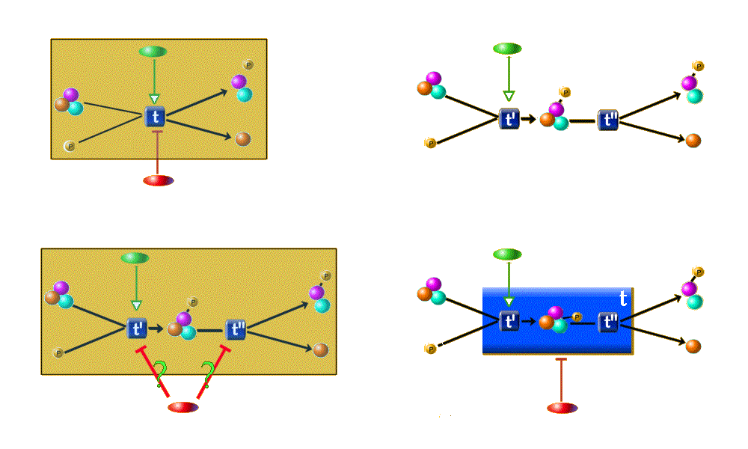
Figure 2-5
(upper left) A very simple pathway resides in the database on which a user makes a query and retrieves the framed region. Note that the user might not be aware of the inhibitor.
(upper right) The user then changes the query result, replacing t with two new transitions, t' and t'', and a new state, and assigning interactions accordingly.
(lower left) When the modified pathway is submitted to the database, an orphan interaction is generated (labeled with '?'). Assignment of this edge is not a simple task as even the user may not know the exact mechanism.
(lower right) A solution to this problem is to convert t to a summary transition and define an inhibitor edge as a meta-edge indicating that our knowledge is incomplete.
In lower right of Figure 2-5, substrates and activator to t' and products of t" are examples of intergraph interactions. The inhibitor interaction in the same picture is an example of a meta edge indicating that the red node somehow inhibits the summary transition (represented with the large blue box). Also note that this summary details the original transition represented in upper left of Figure 2-5. This means that we have the details only for the activation of the mechanism. However the inhibition is represented with a meta edge indicating that our knowledge is inadequate to assess how exactly the inhibition occurs.
A summary transition is bound to the restrictions of an ordinary summary, so it must guarantee that all of its products are produced once it is activated. Therefore no branches are allowed inside summary transitions, since existence of a branch indicates separately regulated elements. Although this may sound like a too tight of a restriction at first, it is important to remember that most biological experiments are actually designed to provide such results. Thus we believe that it will be possible to model most of the incomplete information with this model while maintaining a strong semantic.
Similarly a summary state should guarantee that it actually has a single “state”, that is all states inside it are either present or all is not present, which is pretty difficult so I advise to drop summary states from our ontology [TODO]. Or alternatively we can allow summary states to have combinatorially many “internal states”.
Finally, partial representation of a summary is not allowed; in other words, in any pathway it is contained in, it should be represented with all of its states and transitions together.
In the database, summaries are simply bionodes with a list of members. Each member in turn maintains a list of summaries that contains the member. Nested relations are represented indirectly (i.e., a summary contained in another summary acts as a bridge between its members and the more abstract summary). Summaries can accept edges as their identity (i.e., state or transition). These edges are meta edges and model incomplete information. Edges that are attached to the members of the summary have no explicit relation with the summary. This is currently an active point of argument. An idea is to define the “true” input and outputs of a summary while defining it. This would allow us to ensure that a summaries meaning has not changed after subsequent modifications.
A summary may contain another summary in two different ways. First it can contain it directly as a member. In that case owner summary should not contain the members of the child in order to avoid state duplication. Up to now this was referred as blue path or explicit nesting. Alternatively a summary contains all the members of another summary but not the summary itself. In that case it is important to note that these two summaries are not aware of each other. Although it is worthwhile to check whether including the small summary into larger summary is logical, it may not be possible all the time. In that case these two summaries should be treated as if they were simply intersecting. We call this implicit nesting or black path.
While querying summaries we can use two approaches. We can return a summary only if it is explicitly reached either by a keyword search or by a meta edge. When a summary is returned all of its members are returned inside it as well. Alternatively a summary may be included in a query result when all (some?) of its members are already present in the query. A more important question is the implementation of Nearest Neighbor, the distance between a summary and its members. These issues are not completely decided.
It is important to handle summaries carefully. It makes sense to develop methods, which can detect/remove obsolete summaries. Similarly research users and experts should be warned about such problems and should try to minimize their use of summaries.

Pathway Creation and Manipulation
Chapter
3
This chapter describes how to create and manipulate contents of PATIKA graphs.

Creating and Manipulating PATIKA Graphs
The PATIKA Client opens up with a new empty PATIKA graph with the underlying cell model displayed:
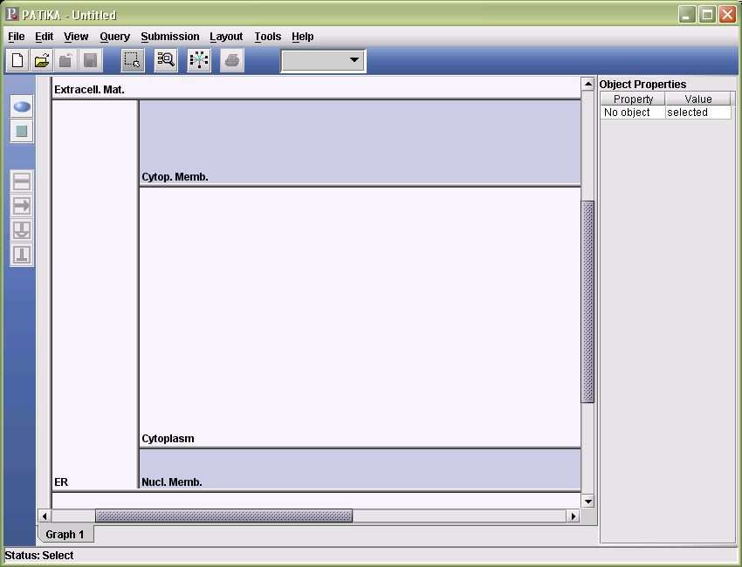
You may populate its contents as described below, save it locally for later use (Section 3.7), and also submit it for integration to the PATIKA database (Chapter 7).
Multiple PATIKA graphs may be opened simultaneously using File | New or File | Open. An existing PATIKA graph may be closed using File | Close. You may switch between PATIKA graphs using their associated tabs displayed at the bottom of the PATIKA window located immediately above the status bar.
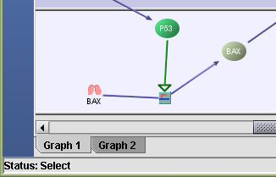

Editing Modes
PATIKA Client has various editing modes, each serving a different set of editing operations:
- Select: When in selection mode, left-click on a biological node or interaction selects that object. If the user left-clicks on no such objects, then a rectangle is initiated that is used for selecting all (possibly multiple) objects within that rectangle. The user can switch to the selection mode by choosing Tools | Select or by simply clicking on the associated toolbox:
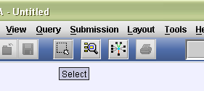
- Marquee Zoom: When in marquee selection mode, left-click initiates a marquee zoom rectangle, which defines the area to which zooming operation is performed upon completion of the rectangle. The user can switch to the Marquee Zoom mode by choosing Tools | Marquee Zoom or by simply clicking on the associated toolbox:
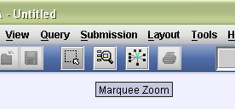
- Create States | Transitions: When in state creation or transition creation mode, left-click within a PATIKA graph’s bounds starts the associated wizard (refer to Section 3.2 and 3.3 for more information on this). The user can switch to the state or transition creation mode by choosing Tools | Create States or Create Transitions or by simply left-clicking on the associated toolbox:
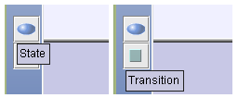
- Define Substrates | Products | Activators | Inhibitors: When in interaction definition mode, the user can identify and link the two biological nodes (a state and a transition) between which an interaction is to be defined (refer to Section 3.4 for more information on this). The user can switch to the interaction creation mode by choosing Tools | Define Substrates or Define Products or Define Activators or Define Inhibitors or by simply clicking on the associated toolbox:
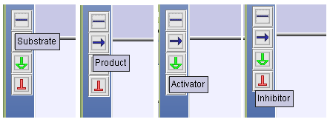

Resizing Compartments
While working with a PATIKA graph, if you would like to resize a certain compartment, you may do so by simply clicking on its bottom (to resize it vertically) or right (to resize it horizontally) boundary (i.e., compartment separator) and dragging until you obtain the desired size. This is especially useful when your PATIKA graphs make heavy use of a compartment (e.g., cytoplasm) or no use of a compartment (e.g., E.R.).
You will notice that when reducing the size of a compartment, a compartment separator will turn red when it comes across an obstacle (bionode) on its way. For instance, in the figure below, the separator between cytoplasm and nucleus membrane is dragged up to shrink the size of cytoplasm. However, the separator cannot be dragged any further up when it hits a biological node (P53 in the cytoplasm in this case) and the separator turns red:
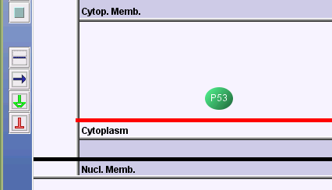

States
A state can be a macromolecule, a small molecule, a complex or even physical phenomena such as light.

Creating States
When in state creation mode, click on the location of the compartment where you would like your new state to be created. This will pop up the State Creation Wizard:
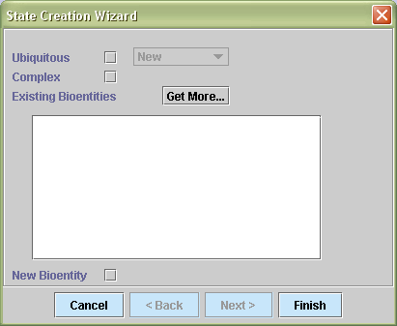
The first step in state creation is for determining the bioentity of the state to be created. If the bioentity of the state you are about to create does not exist in PATIKA database, please check the “New Bioentity” box. If it does, and this bioentity is not currently listed among the list of bioentities provided by the wizard, click on “Get More…” to access it from the database with the help of a query as explained in the following section.

Querying Database for Bioentities
During state creation, the bioentity that the new state is to be associated with may be obtained from the database as follows. First click on “Get More…” popping up the following dialog:
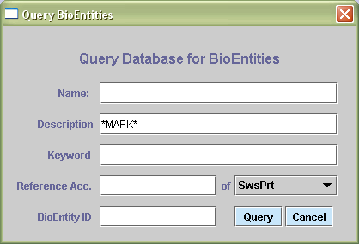
This will allow you to query the database for a bioentity based on a combination of name, description, and keyword. The query will return the list of bioentities satisfying the provided criteria. Select the list of bioentities you are interested in and click on “Add Selected” to append them to the list of existing bioentity list.
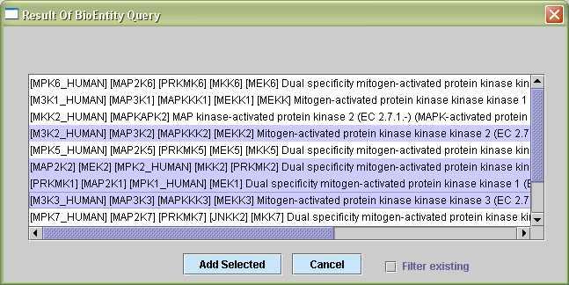

Ubiquitous States
If the state you are about to create is ubiquitous, then check the corresponding box. This will enable the dropdown list of ubiquitous states already in the current PATIKA graph. If your state is one of these, select it; otherwise, by default a new ubiquitous state (not already in the current PATIKA graph) will be created.
Ubiquitous states already in the database may be created as described above.

Complex States
If the state you are about to create is complex, then check the corresponding box. This will enable selection of multiple bioentities from the list. Notice that a single selection is sufficient if the selected bioentity is complex itself.
Once the bioentity that is associated with the state you would like to create is determined, you can proceed with the next wizard page by clicking on “Next>”.
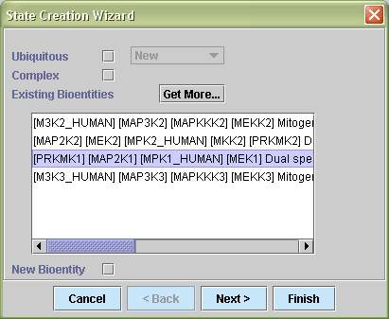
The next step in creating a state is determining whether this state already exists in the PATIKA database. If so, it will be listed in the table of existing states along with any locally created states of the bioentity already chosen in the first step. Select the state you would like to create from this list and proceed to the next page.
If the state does not already exist, click on “New State” and proceed by clicking on “Next>”.
In the example below, the user is about to create a new state (apparently to be the first one in the database) of the bioentity “Dual specificity mitogen-activated protein kinase 6”:
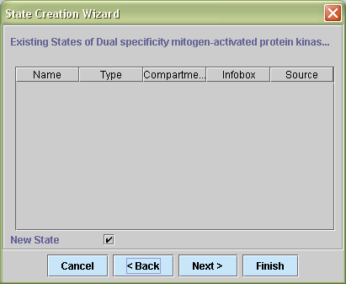
If the state to be created is already in the database (but not in the current PATIKA graph), then you may select it from the table and proceed. In the example below, an existing state of P53 (phosphorylated state of P53 in the cytoplasm) is about to be created:
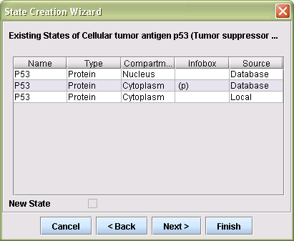
The next step in creating a state is to provide a name, compartment (defaults to the cursor location), description, and type of the state that is about to be created.
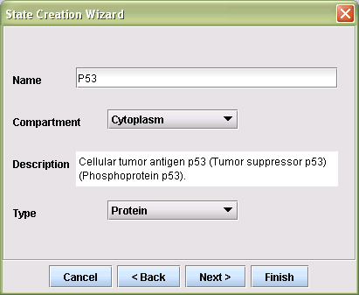
The last step in creating a new state is to provide further information (using text and color) about the state to be used as part of its GUI (Graphical User Interface).
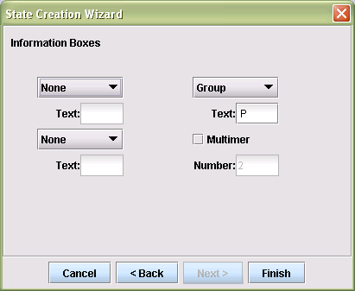
Click on “Finish” to complete the state creation process. For instance, the following is what you would see after creating a state of MAPK in the cytoplasm. The table (inspector) on the right hand side enumerates the properties of this (selected) state as well as the properties of its associated bioentity:
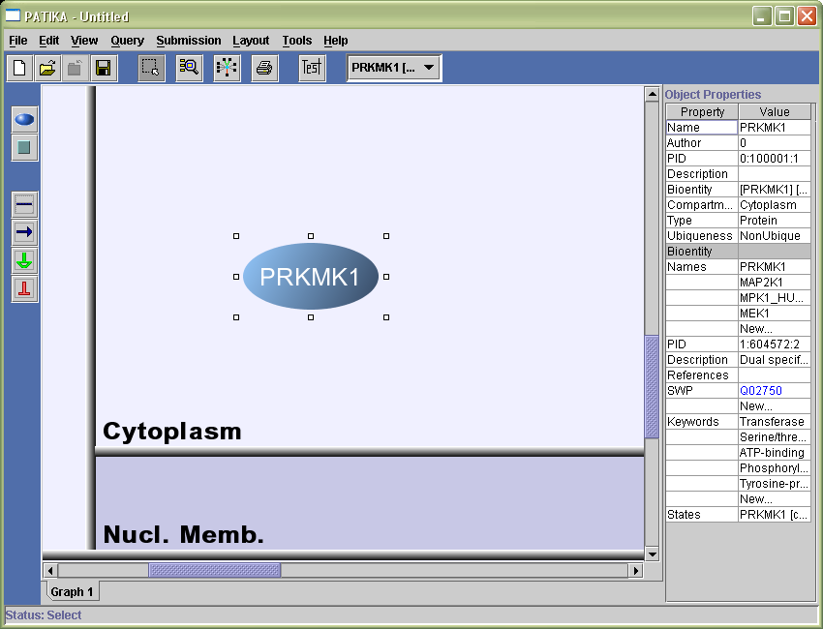

Deleting States
Should you decide to delete a state from the current PATIKA graph, simply select it with the left mouse button, right-click to popup the state popup menu. The state may be removed either locally or from the PATIKA database.
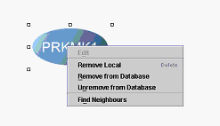
- Local Remove: If you would like to delete a state only locally (but not from the database), then select “Remove Local” from the state popup menu. This will delete the state along with any incoming and outgoing interaction edges from the current PATIKA graph but not from the database (if it is in the database).
- Remove from Database: If you intent to remove it from the database, on the other hand, then select “Remove from Database” from the menu. This will mark the state as removed but it will not be actually removed from the database up until you submit this PATIKA graph:
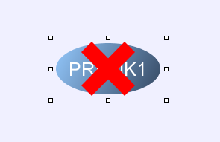
You may undo the removal from the database by selecting “Unremove from Database” in the state popup menu.
Refer to Submitting a PATIKA Graph on page 57 for more detailed information on submissions.

Modifying State Properties
The inspector is responsible for showing and facilitating modification of properties of any graph object. It is viewable by default, and shows the properties of the selected graph object. If you prefer not seeing the inspector, select View | Inspector to disable it.
When you left-click on a state, the inspector will show the state properties such as its name, author, PID, description, and the properties of the associated bioentity. You can interactively change the property values from the inspector unless they are not supposed to change and disabled by the system. In order to protect accidental changes, any state accessed from the database (non-local) will be non-editable by default, and you are required to select “Edit” from its popup menu.

Transitions
A transition represents group additions or removals, complex formations and disassociations as well as transportations and other cellular events.

Creating Transitions
When in transition creation mode, click on the location where you would like your new transition to be created. This will popup the Transition Creation Wizard. First you will be asked to choose a transition type and enter a description:
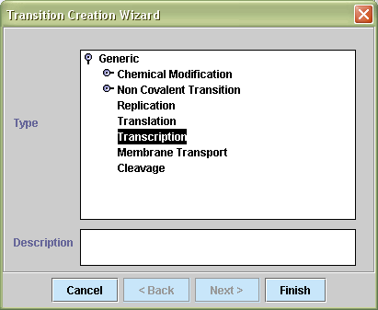
When you click on “Finish”, a transition box will be displayed where you had first clicked. Notice that transitions are not associated with compartments and can be positioned as appropriate.
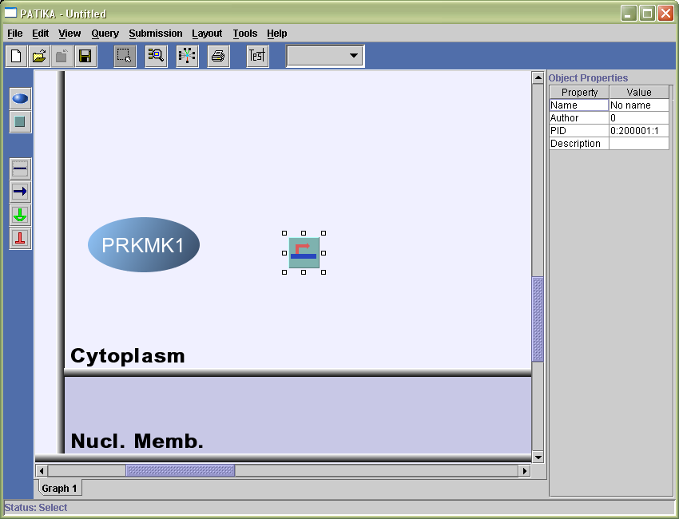
A transition is not meaningful by itself and must have one or more substrates and one or more products, which you can define by linking states to the transition via interactions as described in Section 3.4.

Deleting Transitions
Should you decide to delete a transition from the current PATIKA graph, simply select it with the left mouse button, right-click to popup the transition popup menu. The transition may be removed either locally or from the PATIKA database.
- Local Remove: If you would like to delete this transition only locally (but not from the database), then select “Remove Local” from the transition popup menu. This will delete the transition along with any incoming and outgoing interaction edges from the graph.
- Remove from Database: If you intent to remove it from the database, on the other hand, then select “Remove from Database” from the menu. This will mark the transition as removed but it will not be actually removed from the database up until you submit this PATIKA graph:
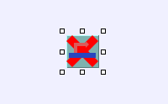
Refer to Submitting a PATIKA Graph on page 57 for more detailed information on submissions.

Modifying Transition Properties
When you left-click on a transition, an inspector window will popup, showing the transition properties such as its name, author, PID, and description. You can interactively change the property values from the inspector unless they are disabled by the system.

Interactions
The relations among biological objects is essential for analysis of cellular pathways. PATIKA facilitates construction of such relations through interactions.

Creating Interactions
There are four types of edges via which the interaction among states are defined:
- Substrate edges: The target and source nodes of a substrate edge define the transition and a substrate of this transition, respectively. In order to be able to create substrate edges, you need to first go into the substrate definition mode as explained earlier. Then you need to left-click on the substrate state and drag it to the associated transition, and release the mouse button while on the transition bounds. Following is an example where PRKMK1 is a substrate of a transition of type transcription:
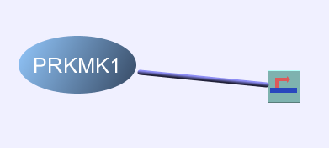
- Product edges: The source and target nodes of a product edge define the transition and a product of this transition, respectively. In order to be able to create product edges, you need to first go into the product definition mode as explained earlier. Then you need to left-click on the transition and drag it to the state that is a product of this transition, and release the mouse button while on the product state bounds. Following is an example where PRKMK1 is a product of a transition of type transcription:
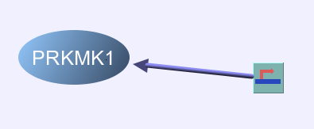
- Activator edges: The source and target nodes of an activator edge define the activating state and the transition that is activated by this state, respectively. In order to create activator edges, you need to first go into the activator definition mode as explained earlier. Then you need to left-click on the activating state and drag it to the transition that this state activates, and release the mouse button while on the transition bounds. Following is an example where PRKMK1 activates a transition of type transcription:
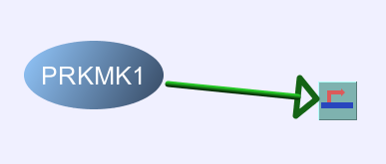
- Inhibitor edges: The source and target nodes of an activator edge define the inhibiting state and the transition that is inhibited by this state, respectively. In order to create inhibitor edges, you need to first go into the inhibitor definition mode as explained earlier. Then you need to left-click on the inhibiting state and drag it to the transition that this state inhibits, and release the mouse button while on the transition bounds. Following is an example where PRKMK1 inhibits a transition of type transcription:
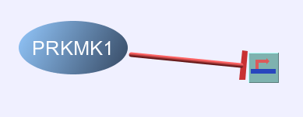
Following is an example where the interaction of a number of states through a transition is shown:
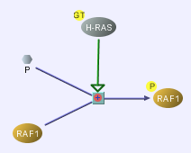

Bioentities
The PATIKA database contains a rather complete set of bioentities; however, you might still need to add new bioentities, and modify the properties of existing ones as described below. The set of bioentities that exist in the current PATIKA graph may be inspected and modified through the Bioentity Inspector available under the View menu.
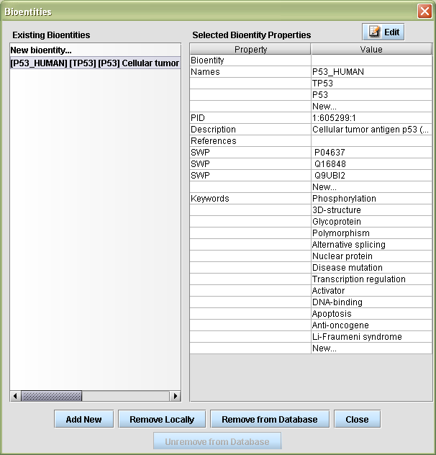

Creating New Bioentities
A new bioentity may be created by simply clicking on “Add New” in the Bioentity Inspector. After that, you may select this newly created bioentity and change its default properties as appropriate.
An alternative way to create a new bioentity is during state creation as discussed earlier by selecting “New Bioentity” in the first page of the State Creation Wizard.

Deleting Bioentities
You may remove bioentities using the Bioentity Inspector either only locally or permanently from the PATIKA database. Normally users should not need to remove existing bioentities from the database however. Notice that remote removals won’t take affect unless you make a submission.

Modifying Bioentity Properties
You may change the properties of an existing bioentity by using the Bioentity Inspector under the View menu by first selecting it and then modifying its properties displayed on the right of the Inspector as desired. However, you are required to click “Edit” before making modifications on existing bioentities to prevent accidental changes.

Invalid PATIKA Graph Topology
There are certain invariants that each PATIKA graph must satisfy so it is sensible from a biological point of view. For instance, each transition must have at least one substrate and at least one product. To perform the consistency check, click View | Consistency. If any inconsistencies exist in the current PATIKA graph, they are listed and highlighted as you click on each inconsistency listed:
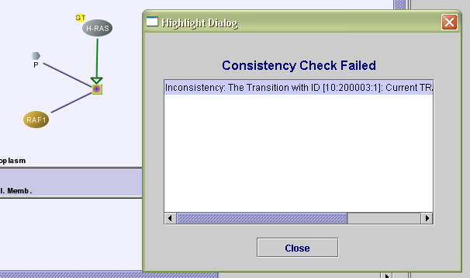

Saving and Restoring PATIKA Graphs Locally
You may save your PATIKA graphs on disk locally for later use (see File | Save). However, you need to be logged in to the PATIKA server to be able to do so; please see “Logging On” on page 56 for more information on this. PATIKA graphs have “.ptk” extension. You can reload an existing PATIKA graph similarly using File | Open.

Pathway Editing and Automated Layout
Chapter
4
Both the topology and the geometry of a PATIKA graph can be changed interactively using the PATIKA Client. The ways in which you may change the topology of a PATIKA graph are described in Chapter 3. Below you will find how the geometry of a PATIKA graph can be changed through operations such as dragging, scrolling and zooming, and automated layout.

Pathway Editing
PATIKA Client has several modes for editing operations as explained in Section 3.1.

Moving
The position of a biological node can be changed by simply left-clicking on the node and dragging it to the desired position and releasing the mouse button when in selection mode.
The drag operation can be applied to a selected group of biological nodes as well. For instance, in the figure below, two states “MDM2” and “p53 dgr” and their associated transition are selected and dragged as a group:
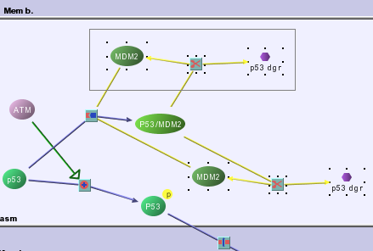

Scrolling and Zooming
The view that the user has of a PATIKA graph can be changed by scroll and zoom operations. Such operations are especially useful when the graph at hand is too large or too small to fit in the display.
Scrolling can be performed by simply using the horizontal and/or vertical scroll bars regardless of the current editing mode. Following is an example where the horizontal and vertical scroll levels are set to visualize the lower left part of the current PATIKA graph:
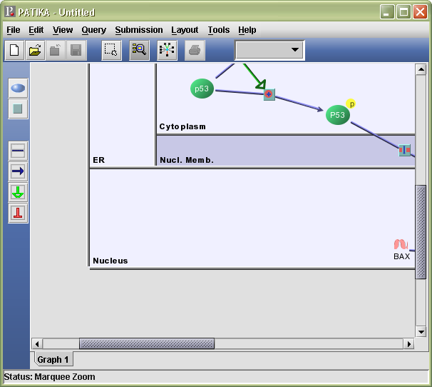
Zooming can be performed either by using the “Marquee Zoom” tool described earlier or by specifying a zoom level through the View menu:
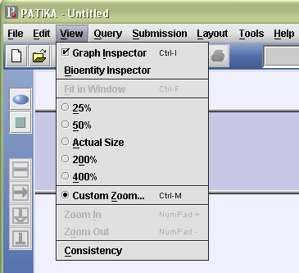
Below you will find an example use of the marquee zoom tool. Suppose one is interested in zooming in to focus on a number of bioentities and their associated interactions. While in marquee zoom mode, create a marquee rectangle enclosing these biological objects:
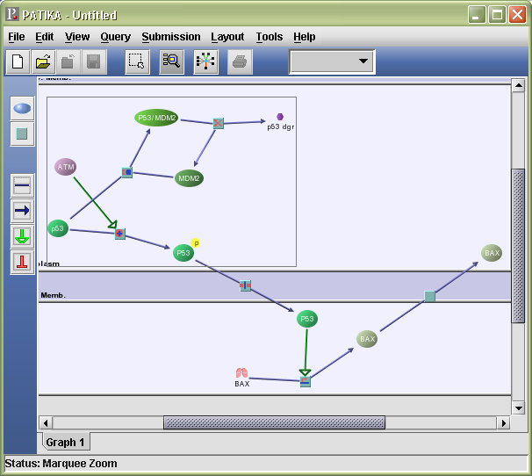
Upon release of the mouse button to complete the marquee rectangle, zoom operation will be performed:
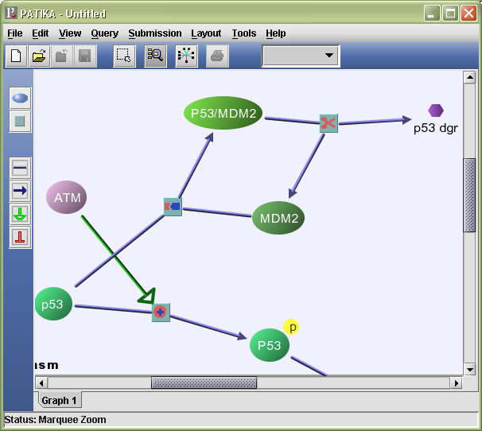

Automated Layout
At any time, the user might choose to rearrange the positions of the biological nodes of the current PATIKA graph by performing an automated layout (Layout | Perform Layout). A poorly laid out pathway diagram confuses the user while a well laid out diagram helps the user better comprehend the underlying data. For instance the following pathway diagram has a random layout:
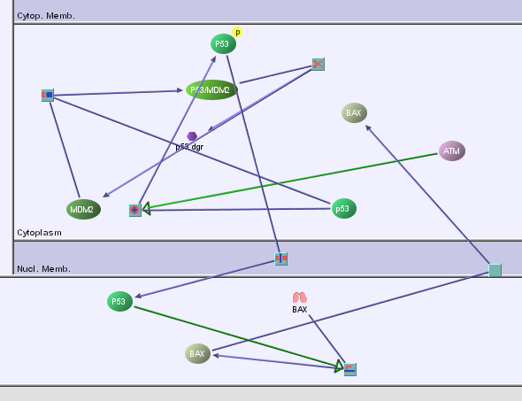
whereas the pathway diagram below shows the same pathway after an automated layout is performed:
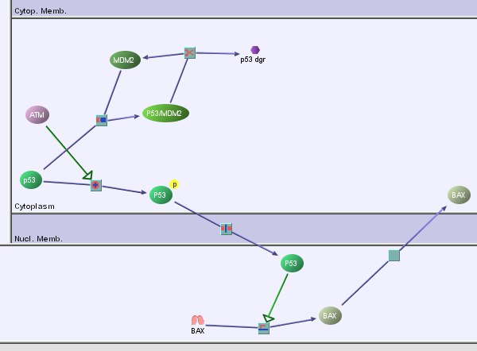
PATIKA performs auto-layout after most operations including queries and submissions.

Updating Pathway Contents
Chapter
5
The PATIKA project aims to form a collaborative effort for collecting signaling pathway information. PATIKA maintains version numbers as part of the ID of each graph object. For instance, the following state has version 1.
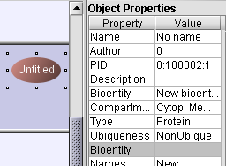
Thus it is possible that while you were working on a PATIKA graph locally, others have changed the topology of your graph and/or properties of states and transitions in the PATIKA database. In that case, some of your local graph objects will have version numbers smaller than the ones in the database making your local PATIKA graph (partially) out-of-date. In other words, you will have an out-dated view of the PATIKA database.
To check whether your current PATIKA graph is up-to-date with respect to the PATIKA database, click Submission | Check Status | All Graph Objects:
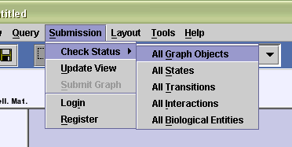
PATIKA will color-code your graph objects to indicate their status as follows:
- Blue: Up-to-date. This graph object exists in the PATIKA database and your local copy is up-to-date.
- Red: Out-of-date. This graph object exists in the PATIKA database with a higher version than you have in the current PATIKA graph.
- Yellow: Local. This graph object does not exist in the PATIKA database.
- Green: Locally Modified. This graph object exists in the PATIKA database but its properties are locally modified.
The following shows a PATIKA graph with objects of various status:
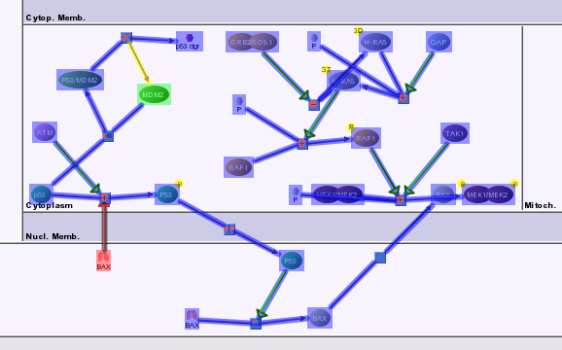
If you have any out-of-date graph objects (objects in red), you may update your view of the database by simply clicking Submission | Update View. For all graph objects that are out-of-date, the system will perform the following check and act accordingly:
- If the object is out-of-date and not locally modified, then it will be updated automatically by the system.
- If the object is out-of-date and it is locally modified, then the local properties of the object along with the properties available in the database are displayed side by side and the user is asked to resolve any conflicts. By default the properties from the database (the properties on the left) are taken, which the user is allowed to modify.
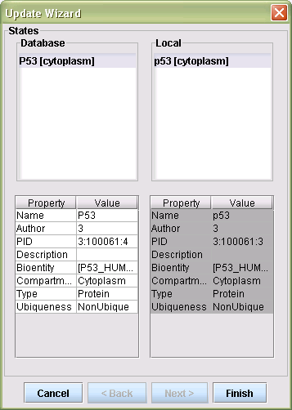
Then the user is expected to click “Finish” to complete the update process. After that, each object in the current PATIKA graph is brought up-to-date (using the properties on the left side), and should have the same version as the ones in the database.

Querying the PATIKA Database
Chapter
6
Every data warehouse needs query tools for extracting meaningful pieces from the big data chunk. The PATIKA project aims not only collecting useful pathway data sent by the users and storing them in an object-oriented database, but also providing access to the desired parts of this big data warehouse via meaningful queries. Since the data is stored in an ordered manner in the database, it is not so hard to extract desired portions of this data if one can provide useful, portable and novel querying tools to users of the system.
This chapter describes how users can query the PATIKA database to form cellular pathways of their interest as PATIKA graphs.

Finding Neighbors
One way the user can query the PATIKA database is through the neighborhood relations among states. In other words, this query lets you “expand” your graph gradually in the desired direction. For instance, if you would like to find out about any states that p53 interacts with, you can query for neighbors of p53 using its popup menu (right-click) as follows:
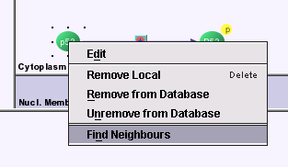
This query results in a new set of states and transitions defining interactions with p53:
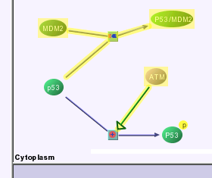
This process can be repeated as desired to further expand the available PATIKA graph.

Querying Bioentities
Often times you will need to access bioentities available in the PATIKA database. This can be achieved through querying. One of the tabs available under Query | Perform Query is “Bioentity”, by which you may query bioentities by a combination of name, description, keyword, etc. The bioentities retrieved through queries are listed in the pane on the left of the Query Wizard. For instance, the following shows how you can query all bioentities whose name start with “mapk”:
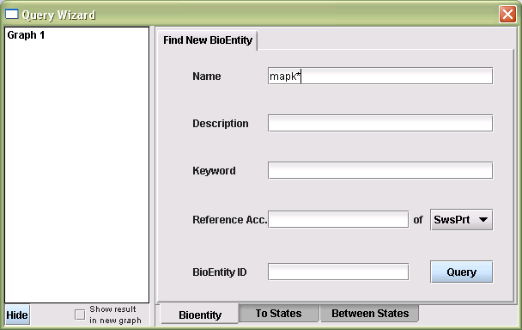
The result of this query is displayed in a dialog:
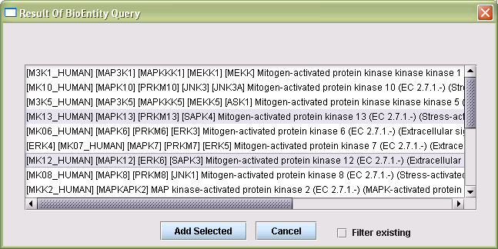
The same dialog may be invoked while creating a new state when you press the “Get More…” button that is located next to the existing bioentity list in the “State Creation Wizard” (see Section 3.2).
The user can then pick any number of bioentities from this list to add to the list of currently available bioentities (displayed on the left of the Query Wizard):
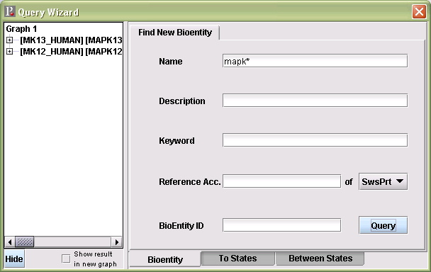
The bioentities added to the list may be used in subsequent queries as needed.

Querying States
The states of a bioentity may be queried using the “To States” tab in the Query Wizard. First, you need to specify which bioentity’s states you are interested in finding by selecting it from the list on the left hand side of the Wizard and then clicking “+” to add it to the list on the right side. For instance, if you are interested in states of bioentity “MAPK13”, select it from the list on the left and then click “+” to add it to the list on the right.
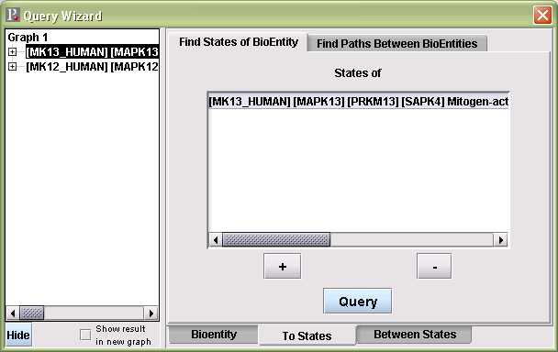
To start the query, simply click on “Query”. The list of states in the PATIKA database of this particular bioentity will be searched for, and the results will be displayed in a dialog. In the example below, no states of “MAPK13” are found to be in the PATIKA database:
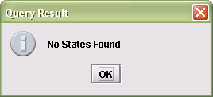
However, if you search for states of the bioentity “P53”:
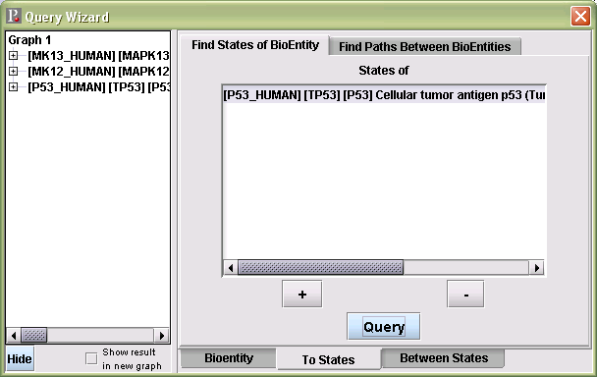
three different states of “P53” are found in the database (one in nucleus and two in cytoplasm - including a phosphorylated state). As a result, these states are added to the current PATIKA graph and highlighted:
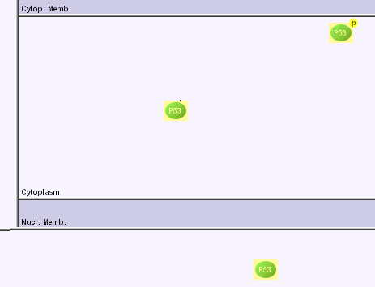
If the checkbox “Show result in new graph” is checked prior to the query, the results are presented in a newly created PATIKA graph.

Specialized Queries
This tool is used for some specialized queries such as neighborhood and shortest path queries. It is located in the menu bar under Database | Perform Query in the “Between States” tab.
First, the user needs to select which of the specialized queries they are interested in by clicking the associated tab near the top of the Wizard window. On the left side of the Wizard, existing PATIKA graphs, their states and associated bioentities are listed.

Finding Neighboring States
To find the neighboring states of a particular state, the user first clicks on the associated tab. Then the user needs to press the “+” button, and select a source node (possibly multiple states) whose neighborhood is to be discovered. After that, the user defines the range of the neighborhood by entering a depth. Finally the user presses the “Query” button to run the query. The results are integrated into the current PATIKA graph in a highlighted form unless the user checked “Show result in a new graph” checkbox.
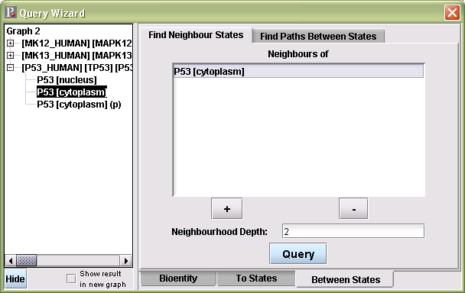
The query will discover the selected state’s neighborhood in the PATIKA database and update the Wizard contents with these contents (the list of bioentities and their associated states on the left hand side of the Wizard):
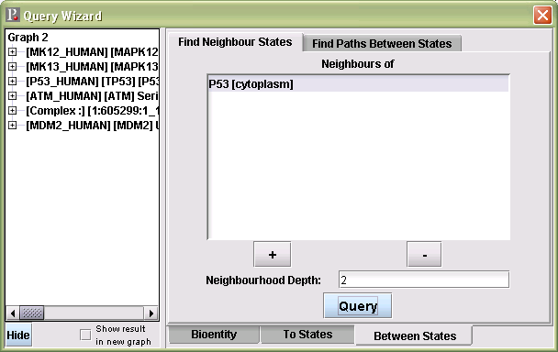
In addition, the current PATIKA graph is updated with the newly found neighboring states and associated transitions in a highlighted form:
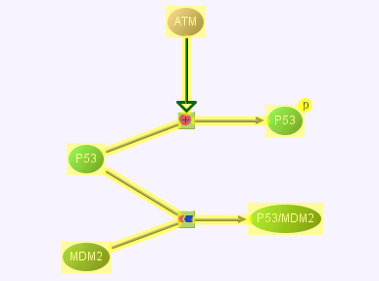

Finding Paths Between States
A second tab in this tool may be used to find paths between two states.
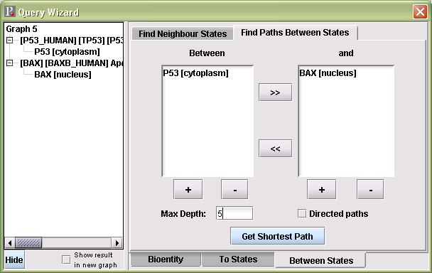
To select the source and target states the user will need to click the associated “+” button. After a maximum depth is provided, the user may press the “Get Shortest Path” button to execute the query. Again, the returned path between the specified states will be integrated into the current PATIKA graph (where the new contents are highlighted) unless the user checked “Show result in new graph”. A checkbox named “Directed Paths” is provided to specify whether the direction of the paths (interactions) should be taken into account or not.
For instance, if you query the shortest path between a P53 state in cytoplasm and a BAX state in nucleus with a maximum depth of 5, you will obtain the following pathway:
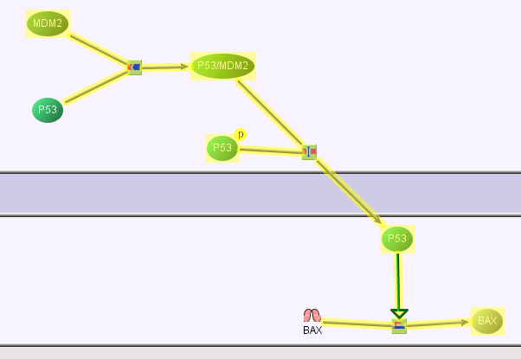
The Query Wizard contents will be updated with the newly found states and their associated states as well:
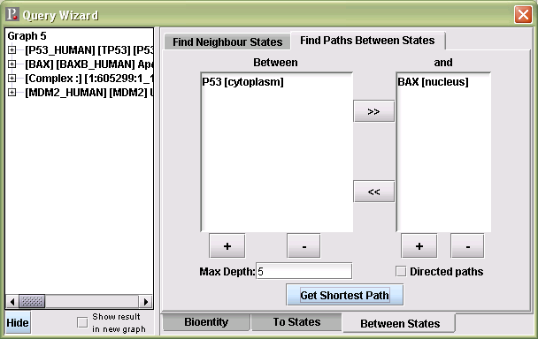

Populating the PATIKA Database (Research & Expert Users Only)
Chapter
7
This chapter describes how users can populate the PATIKA database through submissions. Through such submissions the PATIKA database will accumulate available knowledge in signaling pathways. However, you must be a research or expert user in order to be able to make submissions to the database. Please contact the PATIKA staff if you would like to gain submission privileges.

Logging On
Before making a submission, you are required to log on (we assume you have already registered to download the PATIKA Client). To log on, click on Submission | Login:
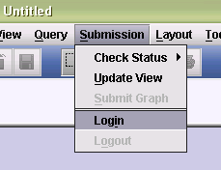
Enter your username and password, and click on “OK” as prompted to complete the login process:
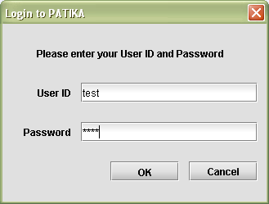
You should get the following message assuming your login information is valid:
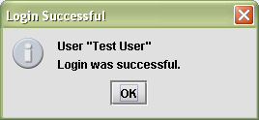

Submitting a PATIKA Graph
Once you are logged in as a research or expert user, you may click on Submission | Submit Graph to start a submission:
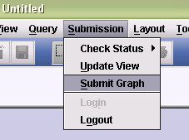
This will pop up the submission wizard. Please fill in a description about the submission here, and click “OK”:
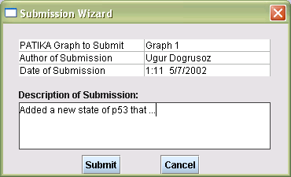
The submitted PATIKA graph will be compared against the complete network of graphs currently in the PATIKA database. It is possible that some inconsistencies between the user’s view (the submitted PATIKA graph) and the entire graph in the database are discovered. For instance, the view the user has of a state might be out of date because of a prior submission (e.g., modification in the state name). If such an inconsistency occurs, the user is notified of this discrepancy, and asked to update their view (refer to Chapter 5 for details). Otherwise, the submission should be successful:
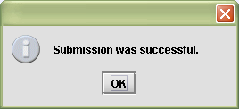
For each successful submission, up-to-date and locally modified PATIKA graph contents will have their version numbers incremented by 1.

